LAB TEST-2

ASSISTED CODING LAB
2503A52L04
SET:G

TASK:1
G-1:
QUESTION: Ad-hoc CSV exports in digital media streaming contain missing/invalid numeric fields.

Sum the 'value' column as int, skipping invalid rows, and report total (print skipped count
optional).
Data & Edge Cases:
id,value
1,10
2,NA
3,7 -> 17 with one skipped.
AI Assistance Expectation:
Use AI to draft robust CSV parsing with try/except and tests

PROMPT:


CODE:
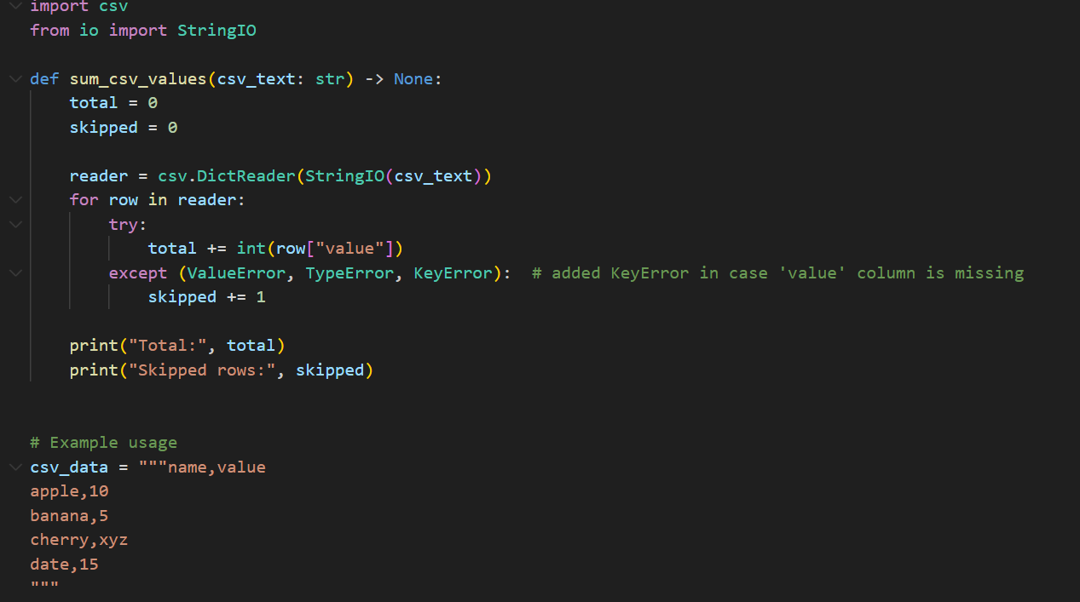

OUTPUT: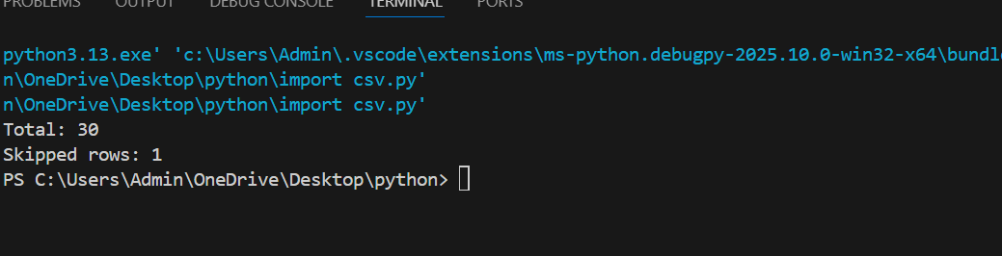

G-2
QUESTION: Two CSVs in digital media streaming must be merged by 'id' for reporting
Implement inner and left joins without pandas, following SQL semantics.
Data & Edge Cases:
A:id,price & B:id,qty -> inner join has only common ids; left join keeps all A with None for
missing B.
AI Assistance Expectation:
Use AI to outline dict-building and join logic; write unit tests for both joins.
Constraints & Notes:
No external deps; stable output order preferred
PROMT:
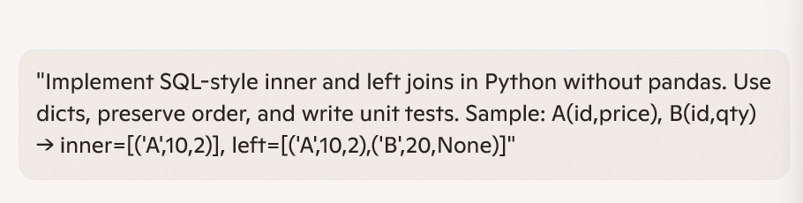
CODE: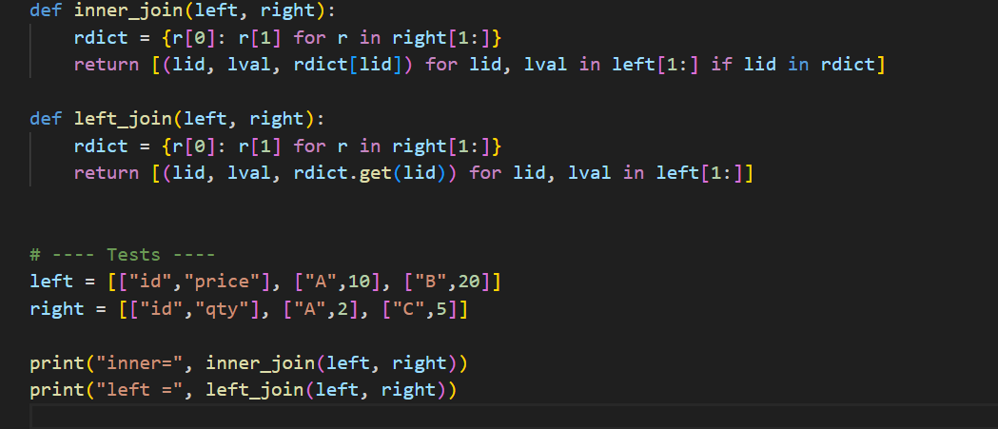
OUTPUT: